**Scenario 10 Evaluation for the Sample Id: FUAFHE**

**Moderate to Severe Evaluation**

Cats and dogs: Any two of the following:

(

High Red Flag Megamonas OR

High Red Flag Sutterella OR

High Red Flag Collinsella OR

Low Red Flag Bacteroides OR

Low Red Flag Blautia

);

OR

Dogs:

8 or more Yellow flags OR 8 or more Red flags;

Cats:

11 or more Yellow flags OR 9 or more Red Flags;

-------------------------------------------------------

**High red megamonoas, suttrella, collinsella & Low Yellow Blautia, bacteriorides got failed.**

**Low Yellow bacteriorides got passed.**

Species: **DOG**

Total No.of Yellow Flags Found: **04 (Failed)**

Total No.of Red Flags Found: **04 (Failed)**

**Moderate to severe** Evaluation Result: **Failed.**

Attached the Screenshot Below

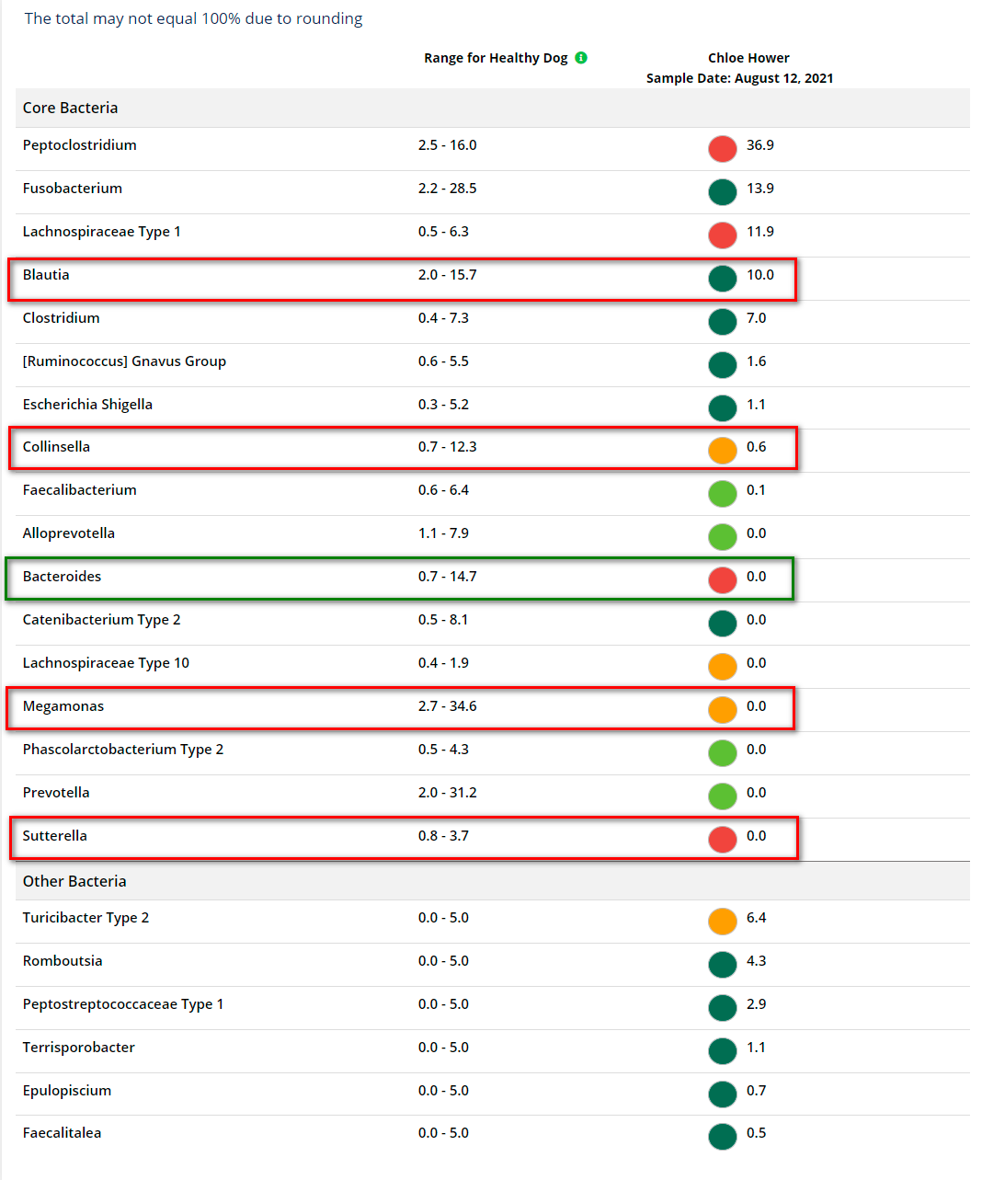

**Mild to Moderate Evaluation**

Cats and dogs:

Any Two

(High Yellow Flag Megamonas OR

High Yellow Flag Sutterella OR

High Yellow Flag Collinsella OR

Low Yellow Flag Bacteroides OR

Low Yellow Flag Blautia

)

OR

Dogs:

4-7 Yellow Flags OR 5-7 Red Flags;

Cats:

8-10 Yellow Flags OR 5-8 Red Flags;

OR

Cats/Dogs Dietary Recommendations:

Increase Fiber

OR

Increase Protein

OR

Decrease Crabs

-------------------------------------------------------

**High Yellow megamonoas, suttrella, collinsella got Failed.**

**Low Yellow blautia & Low Yellow bacteriorides got failed.**

Species: **DOG**

Total No.of Yellow Flags Found: **04 (Failed)**

Total No.of Red Flags Found: **04 (Failed)**

**Dietary Recommendation: (Passed)**

Increase Fiber.

**Mild to Moderate** Evaluation Result: **Passed**

Attached the Screenshot Below

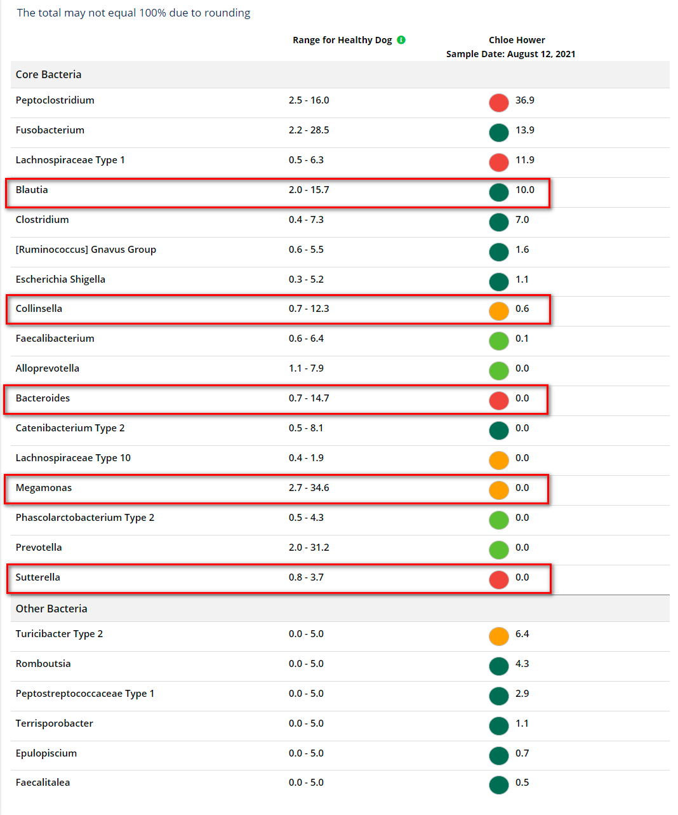

**Expected Result:** **Mild to Moderate**

**Actual Result:** **Mild to Moderate**

**Summary Gauge Chart Shows the Actual Result.**

